**CIRCUIT DIAGRAM :**

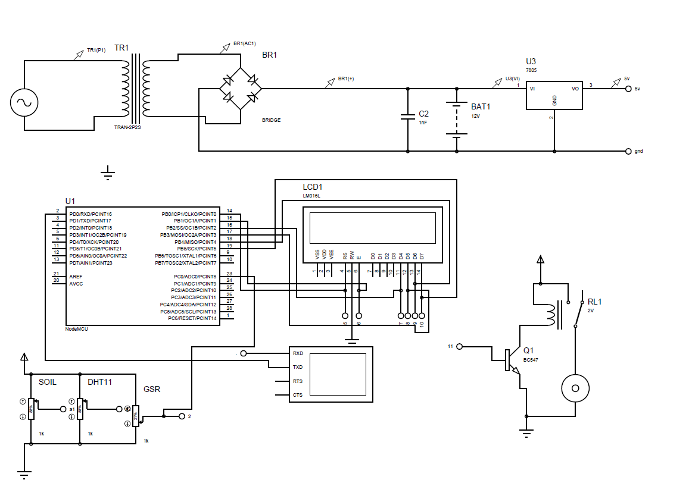

**CODE**:

#include <LiquidCrystal.h>

LiquidCrystal lcd(8,9,10,11,12,13);

void setup()

{

lcd.begin(16, 2);

lcd.setCursor(0, 0);

lcd.print("Smart System");

delay(2500);

lcd.clear();

Serial.begin(9600);

pinMode(7,OUTPUT);

void loop()

{

int SM = analogRead(A4);

int DHT = analogRead(A5);

int GSR = analogRead(A1); GSR=GSR/100;

lcd.setCursor(0, 0); lcd.print("SM:"); lcd.print(SM);lcd.print(","); lcd.print("GSR:"); lcd.print(GSR);

lcd.setCursor(0, 1);

int Temp=DHT/10;

lcd.print("Temp:"); lcd.print(Temp); lcd.print(",");

if(Temp>98)

{

Serial.println("High Temperature detected");

float Humidity=DHT/18.56;lcd.print("Hu:"); lcd.print(Humidity);

}

if(Temp<88)

{

Serial.println("Low Temperature detected");

float Humidity=DHT/6.56;lcd.print("Hu:"); lcd.print(Humidity);

}

if(GSR>8)

{

Serial.println("High GSR detected");

digitalWrite(7,1);

}

else

{

digitalWrite(7,0);

}

delay(1500);

lcd.clear();

}

OUTPUT:

